Tangerine
By: Edward Bloor

Paul Fisher sees the world from behind glasses so thick he looks like a bug-eyed alien. But he’s not so blind that he can’t see there are some very unusual things about his family’s new home in Tangerine County, Florida. Where else does a sinkhole swallow the local school, fire burn underground for years, and lightning strike at the same time every day? The chaos is compounded by constant harassment from his football-star brother, and adjusting to life in Tangerine isn’t easy for Paul—until he joins the soccer team at his middle school. With the help of his new teammates, Paul begins to discover what lies beneath the surface of his strange new hometown. And he also gains the courage to face up to some secrets his family has been keeping from him for far too long. In Tangerine, it seems, anything is possible.

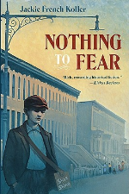

Nothing to Fear
by
Jackie French Koller

Thirteen-year-old Danny and his family are struggling to make ends meet in New York during the Great Depression. His father leaves to search for work, and Danny and his mother do what they can to survive. With his mother pregnant and unable to help, Danny is forced to beg for food. Through it all, they retain their good humor and family pride, and in the end help arrives in a most unexpected guise.

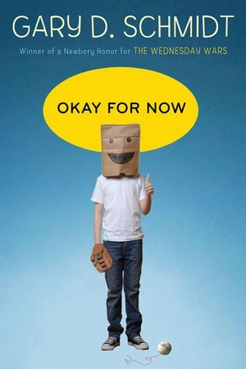

Okay for Now
by
Gary D. Schmidt

Midwesterner Gary D. Schmidt won Newbery Honor awards for Lizzie Bright and the Buckminster Boys and The Wednesday Wars, two coming-of-age novels about unlikely friends finding a bond. Okay For Now, his latest novel, explores another seemingly improbable alliance, this one between new outsider in town Doug Swieteck and Lil Spicer, the savvy spitfire daughter of his deli owner boss. With her challenging assistance, Doug discovers new sides of himself. Along the way, he also readjusts his relationship with his abusive father, his school peers, and his older brother, a newly returned war victim of Vietnam.

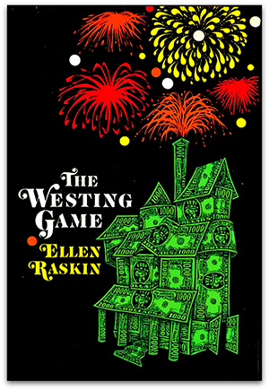

The Westing Game
by
Ellen Raskin

A bizarre chain of events begins when sixteen unlikely people gather for the reading of Samuel W. Westing's will. And though no one knows why the eccentric, game-loving millionaire has chosen a virtual stranger - and a possible murderer - to inherit his vast fortune, one thing's for sure: Sam Westing may be dead... but that won't stop him from playing one last game!

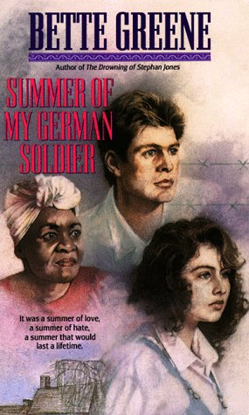

Summer of My German Soldier
by Bette Greene
Minutes before the train pulled into the station in Jenkinsville, Arkansas, Patty Bergen knew something exciting was going to happen. But she never could have imagined that her summer would be so memorable. German prisoners of war have arrived to make their new home in the prison camp in Jenkinsville. To the rest of her town, these prisoners are only Nazis. But to Patty, a young Jewish girl with a turbulent home life, one boy in particular becomes an unlikely friend. Anton relates to Patty in ways that her mother and father never can. But when their forbidden relationship is discovered, will Patty risk her family and town for the understanding and love of one boy?

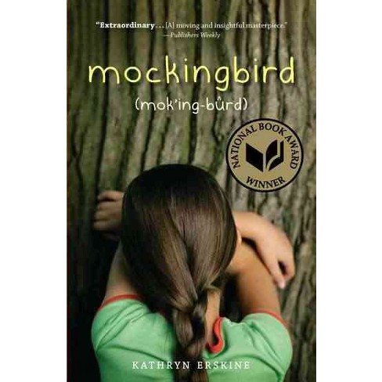

Mockingbird

by Kathryn Erskine

Caitlin, a bright, talented 10-year-old girl with Asperger's Syndrome, is trying to understand the world around her, especially how to make friends and fit in at school. She also has to deal with the tragic shooting death of her brother, who had been her main support, and the pain of her father, who seems lost in grief over the killing of his son. As is true with most girls with Asperger's, Caitlin is intelligent, but "getting it," that is, understanding emotion or interpreting social behavior, is almost impossible. She has to use her intellect, the Facial Expressions Chart, and much verbalizing to herself to get it right. The reader sees all this from within Caitlin's mind, and it could not seem more real. Finally, with the help of her very understanding school counselor, the friendship of a younger boy, and the kindness of one of her classmates, she breaks through, and begins to understand empathy. As Caitlin starts to "get" compassion, so do those around her.

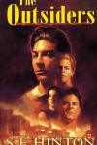

The Outsiders

by S.E. Hinton

THE OUTSIDERS has been one of the most popular book among teens and preteens since it came out in 1967. Ponyboy and his Greaser gang fight rival gang the Socs (short for "Socials," the wealthier, more preppie kids) and try to make a place for themselves in the world. The juvenile delinquent characters are fully and humanely developed in this realistic look at life, death, and growing up, told from a teen's point of view. The book was based on the author's high school experience in Tulsa, OK, in 1965, but the time and setting are not specified in the text.

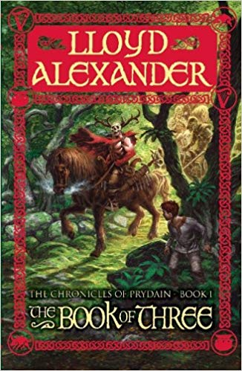

The Book of Three

(The Chronicles of Prydain #1)
by
Lloyd Alexander
Taran wanted to be a hero, and looking after a pig wasn't exactly heroic, even though Hen Wen was an oracular pig. But the day that Hen Wen vanished, Taran was led into an enchanting and perilous world. With his band of followers, he confronted the Horned King and his terrible Cauldron-Born. These were the forces of evil, and only Hen Wen knew the secret of keeping the kingdom of Prydain safe from them. But who would find her first?

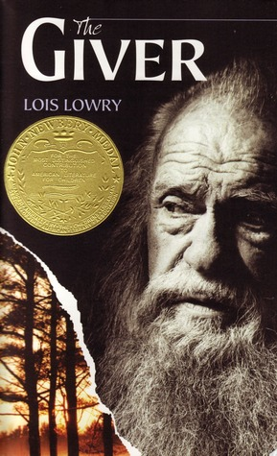

The Giver
by Lois Lowry

Twelve-year-old Jonas lives in a seemingly ideal world. Not until he is given his life assignment as the Receiver does he begin to understand the dark secrets behind this fragile community.

