Mass Media Techniques Pre-Test
- Name Calling or Innuendo

- Glittering Generalities / Card Stacking

- Bandwagon
- Testimonials
- Appeal to Prestige, Snobbery, or Plain Folks

- Appeal to Emotions

Part 1: Read the following descriptions, and identify which techniques are being used.

- A commercial for a weight loss program promises success by showing you pictures of five consumers of the product who each lost over fifty pounds in a three-month period. However, the advertisers don’t give you any information about the other ninety-five people who tested the product.
This technique is known as:

- The ASPCA (animal shelter) shows heartbreaking pictures of abandoned animals and tell their touching stories in an attempt to persuade people to consider adopting one as a pet.
This technique is known as:

- A company is advertising their next generation cell phone and suggests that you will not be keeping up with the times if you don’t purchase this phone. In other words, you are going to be left out if you don’t have this cool, new phone.
This technique is known as:

- A political advertisement for someone running for governor suggests that the candidate for the other party is dishonest.
This technique is known as:

- A large athletic company uses Michael Jordan to endorse their new line of basketball shoes. Michael Jordan acknowledges that this shoe is the most comfortable one he has ever worn and is a must for a higher level of performance on the court.
This technique is known as:

- An ordinary family sits together at the table for a meal – they eat Kraft macaroni and cheese with their meal.
This technique is known as:

Part 2: View selected commercials as instructed by your teacher. Describe the commercial that best fits each of the six techniques.

- Name Calling / Innuendo_____________________________________________
_________________________________________________________________

- Glittering Generalities / Card Stacking __________________________________
_________________________________________________________________

- Bandwagon _______________________________________________________
_________________________________________________________________

- Testimonials ______________________________________________________
_________________________________________________________________

- Appeal to Prestige, Snobbery, or Plain Folks _____________________________
_________________________________________________________________

- Appeal to Emotions _________________________________________________

- 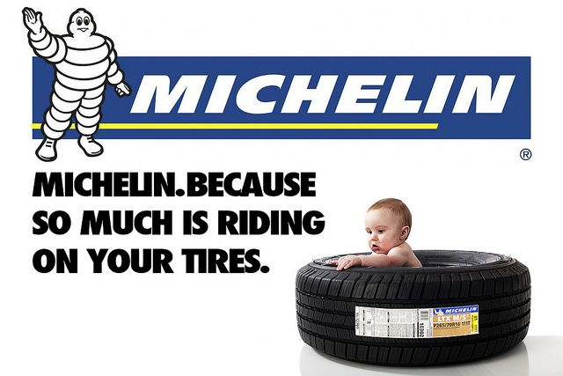

- 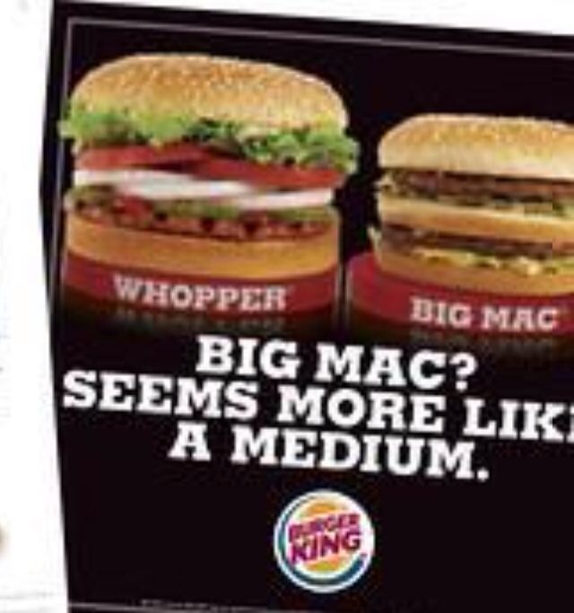

Mass Media Techniques Post-Test
- Name Calling or Innuendo

- Glittering Generalities / Card Stacking

- Bandwagon
- Testimonials
- Appeal to Prestige, Snobbery, or Plain Folks

- Appeal to Emotions

Part 1: Read the following descriptions, and identify which techniques are being used.

- A commercial for a charity displays photos of dirty and emaciated children dressed in ragged clothes. The voiceover provides details about their difficult lives in an attempt to get viewers to help address the children’s needs by contributing to the charity.
This technique is known as:

- A commercial for a fast food chain includes an appealing image of crispy fries with the words 30% less fat, 40% fewer calories and 100% more taste in a large bold font.
This technique is known as:

- A commercial for a hairspray features Ariana Grande who claims that she uses the product and that it provides a hold that lasts even throughout the most strenuous concert appearance.
This technique is known as:

- A spokeswoman for a grocery store chain beams as she observes her family gathered around a table and sharing a meal that she has prepared with ingredients purchased from that store.
This technique is known as:

- An advertisement affirms that “real men” use a certain after shave.
This technique is known as:

- An advertisement for a soft drink company features “hidden camera footage” of a competitor’s delivery man surreptitiously buying its product from a vending machine.
This technique is known as:
:

Part 2: View selected commercials as instructed by your teacher. Describe the commercial that best fits each of the six techniques.

- Name Calling / Innuendo_____________________________________________
_________________________________________________________________

- Glittering Generalities / Card Stacking __________________________________
_________________________________________________________________

- Bandwagon _______________________________________________________
_________________________________________________________________

- Testimonials ______________________________________________________
_________________________________________________________________

- Appeal to Prestige, Snobbery, or Plain Folks _____________________________
_________________________________________________________________

- Appeal to Emotions _________________________________________________
_________________________________________________________________

Post Test Examples

- 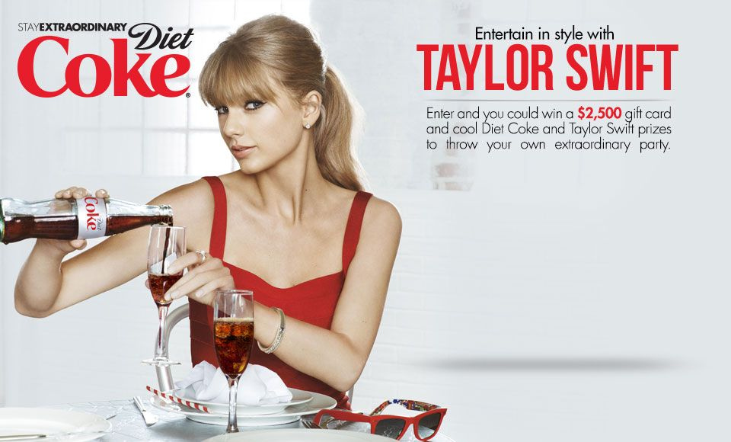

2.

3.

4.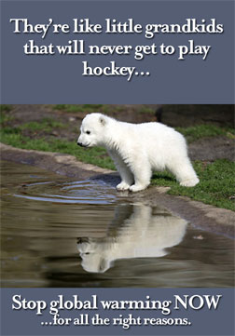

5.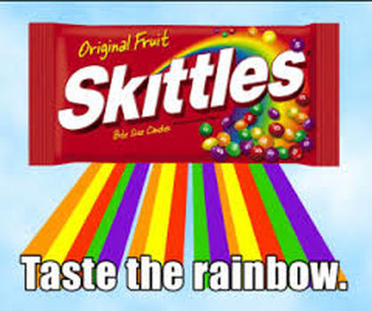
6. 